**Building an Online Blood Donation Management System**

by

FAHAD ALKHUDAIR AND KHALID ALAWAD

Advisor

PROFESSOR EKCROTH

A senior research paper submitted in partial fulfilment for the requirements

for the degree of Bachelor of Science

in the Department of Mathematics and Computer Science

in the College or Arts and Science

at Stetson University

Deland, Florida

Spring Term

2022

# **Acknowledgements**

[This acknowledgments page is optional. Decide what to put in here on remove it altogether.]

**Table of Contents**

**Acknowledgements** 2

**List of Figures** 5

**List of Tables** 6

**Abstract** 7

**1.** **Introduction** 8

**2.** **Related works** 9

**3.** **Online blood management system overview** 11

**3.1.** **Donation Types** 11

**3.2.** **Staff Roll** 12

**3.3.** **Campaign (Blood Drive) Management** 12

**3.4.** **Appointments** 12

**3.5.** **Questionnaires** 13

**3.6.** **Donations** 13

**4.** **ONLINE BLOOD MANAGEMENT DESIGN** 14

**4.1.** **Database** 14

**4.2.** **Implementation Options** 15

**4.3.** **Implementation technology** 15

**4.4.** **Use Interface** 15

**5.** **Conclusion** 19

**6.** **Limitations and Future Works** 20

**7.** **References** 21

# **List of Figures**

Figure 1 Login Page 16

Figure 2 Signup Page 16

Figure 3 Profile Update Page 17

Figure 4 Donation Component Page 17

# **List of Tables**

# **Abstract**

"Online Blood Donation Management System" connects health service providers with voluntary blood donors through a common online web-based platform. Connecting volunteer blood donors to nearby blood drives, is the main objective of this project. The Online Blood Donation Management System (OBMS) provides management functions to the registered health provider institutions enabling them handle the entire donation process from appointment scheduling all through to donation. The technology platform used in the implementation of this system uses the Node.js environment with React, HTML5 and CSS3 for the frontend, ExpressJS for the backend and MongoDB for the database.

# **Introduction**

Blood is an essential component in healthcare necessary for various medical procedures such as organ transplants, accidents, cancer therapy amongst others. Though critical, it remains a limited resource leading to suffering and/or death due to lack of access to safe blood transfusion [1,2]; it is estimated that ten million units are required annually in the USA [3] with someone in need of blood or platelets every 2 seconds. To meet demands, health providers, blood banks and other affiliated institutions conduct blood drive campaigns to mobilize the general public towards donation of blood; this has more often than not led to resource wastages especially during Mass Casualty Events (MCE) [4]; with an estimated 5% of individuals in the USA donating blood [5], better systems need to be in place to increase donation efficiency and collection pool so as to guarantee and adequate national supply of blood in the future.

The main objective of this project is to develop an online web-based system to automate the management of the collection phase in the lifecycle of a blood bag - donors, blood collection and screening [3], by providing a secure, centralized management system for health providers for both administrative, inventory and donor management. The system is designed to facilitate the efficient co-ordination between demand and supply of blood, address the several drawbacks of both the semi-automated and manual systems with regards to record management, reporting, scheduling and reduce on time and resource wastage on redundant tests during collection.

# **Related works**

Various blood bank databases are operational – a google search of the same yielded over 100 results; however, due to their pluralistic system of collection, no centralized repository inventorying blood or blood components collected exists [6]. This presents a major drawback particularly during Mass Casualty Events (MCE) as the actual blood inventory cannot be reliably predicted necessitating calls for blood donations that yield a surplus that ends up being wasted [4].

One of such systems is one provided by American Red Cross. The system coupled with its mobile application impressive reviews and has facilitated the Red Cross through its mobilization efforts collect over 45% of the total blood collected in the United States. Included in this list also, is the America’s Blood Centers’ which provides an online system to manage donation process amongst blood centers. The main issue with these systems and others is the lack of direct connectivity with the hospitals where the blood is to be utilized, thus making effective inventory control of blood assets elusive and leads to wastage due to unnecessary mobilization for blood. Some of these systems also employ intrusive technology in order to track and match potential donors which is a nightmare in this age of privacy especially online.

Our system aims to overcome this discrepancy in inventory reporting and demand prediction by providing a common platform with a centralized repository for all blood collection services for the various sources like Non-Governmental Organizations (NGOs), Hospitals, Blood Banks etc. This will also reduce on the wastage of resources associated with unnecessary blood drive campaigns and redundant tests as a result of receiving donations from deferred donors.

Our system aims to provide a link between the voluntary donor and the health service provider that needs replenishing their inventory. This we intend to achieve while avoiding the intrusiveness of the various proposed and/or implemented mobile app blood management systems that constantly query user location to update donor information for their algorithmic donor location, matching, call and/or text routing and donor-recipient pairing. The system will enhance data accuracy by doing away with physical forms necessary during the collection process.

# **Online blood management system overview**

OBMS will be an online web-based application that will provide the volunteer donors the platform to register and query available blood drive locations and make appointments for donation; the health providers should be able to manage their blood drive campaigns, manage their blood inventory, query availability of particular blood and/or blood components urgently required from other health providers. A central repository will be maintained and each health provider's data partitioned within the database and appropriate mechanisms for cross-querying of necessary information such as urgently required blood or blood component not currently in the provider’s inventory provided for.

The below subsections will provide details of the individual features that OBMS provides. Section 3.1 details how we implement donation types, section 3.2 details the staff roll, section 3.3 details the campaign management, section 3.4 details the appointments, section 3.5 details the donations, and section 3.6 details the current limitations of and possible future additions to our system.

# **Donation Types**

OBMS provides a centralized feature for management of the registration of the various blood donation types. This feature is only accessible for modification by the global system administrator so as to provide a uniform set of types for donation across all health providers registered on the system.

This allows the global administrator to set common information on blood components such as the types to be donated, frequency of donation, brief description to be presented to the donors to determine kind of donation to make, and finally the period for which the type of donation is viable. These parameters are also used in inventory control to notify the health providers of blood components that are about to go bad so that they can be prioritized for use, or those that have already gone bad so that they can be discarded.

# **Staff Roll**

OBMS allows the various health providers to maintain a roll of medical staff who’ll engage in their campaign drives and aid in the blood collection processes. These staff members need not necessarily be regular staff of the health provider but can be volunteer professionals for the purposes of the particular event(s).

This feature allows each health provider to add medical practitioners, subject to due verification of their credentials, to the staff role and alternatively delist them when their services are no longer required. This feature promotes volunteer behaviour in these events amongst the medical professionals.

# **Campaign (Blood Drive) Management**

This feature helps health providers in managing their blood drive campaigns. The data is partitioned by health provider allowing only their authorized personnel to manage blood drive events. A date and location for the events can be populated and queried; appointment slots are also defined allowing for potential donors to book appointments and this also helps in managing overcrowding and unnecessary wait times at the blood drive centers.

# **Appointments**

OBMS provides an appointment booking feature to help streamline the entire blood collection processes. Appointment slots are created for the various blood drive campaigns by the health providers and the potential donors can pick an available appointment slot. This helps in streamlining the entire collection processes by cutting down on unnecessary queues and wait times.

# **Questionnaires**

OBMS provides this feature so as to cut down on the wait times during the collection process. The potential donor is provided questionnaire during appointment booking containing standard questions necessary to determine suitability to make donation. This information is reviewed prior to the campaign day and any donor who fails is notified and the appointment slot opened for another potential donor to make the appointment.

This feature is controlled by the global administrator of the system who designs the questionnaire forms based on the national guidelines and thus provides a standardized form across all health providers. Only a single questionnaire can be active at any one particular time and. The feature together with the appointments feature helps cut down on unnecessary queues of not potential candidates at the blood drive centers.

# **Donations**

OBMS keeps track of all donations made and makes this information available for querying to all registered health providers. The blood bags are inventoried and necessary metadata such as donor, questionnaire and physical exam result are stored. Also stored are the lab results immediately they are made available after successful testing of the donated blood samples.

This feature is controlled by the health providers but allows for cross-querying for matching blood component available in other health providers blood banks and allow for making of requests for the same.

# **ONLINE BLOOD MANAGEMENT DESIGN**

# **Implementation Options**

To provide cross platform compatibility, it was decided that a browser-based system to be preferable. A modern cross-browser framework was desired and out of the various options presents including but not limited to: Blazor/Asp.Net, Symfony, MARN (Mongo, Angular, React.js & Node.js); we settled on the MERN stack: MongoDB [9], Express.js [10], React [11] and Node.js [12]

# **Implementation technology**

The system will feature two distinct applications – frontend and backed. The backend will be based on the Node.js platform and will run an Express.js server. The backend will be responsible for serving, mutating and handling all logic related to data requests. The frontend will be done using HTML5, CSS3 and JavaScript implemented using the React.js library.

In addition, the system will implement JSON Web Token (JWT) [13] as the authentication mechanism to secure communication between its front and back ends; furthermore, authorization through context-based access control will be modelled based on HIPPA regulations and implemented as means of deciding that the system user has the proper permissions access particular data due sensitivity of patient health information.

# **Database**

The database will be based on MongoDB as it is well suited to handle large data more efficiently than relational databases, it’s easier to use and maintain and performs better [8]. The database will contain various collection to maintain the various data required by the system. Among the collections available include:

1. **Users’ collection:** Maintains all authorized users’ credentials. This consists of a unique username per user, an encrypted password and the designated user role.
2. **Profiles collection:** Maintains basic details about the users’ including names, date of birth, social security numbers, contacts and addresses.
3. **Staff collection:** Maintains details of staff for the various health providers which include the health provider ID, staff ID and staff profession.
4. **Questionnaires collection:** Maintains the questionnaires and their related multiple-choice questions.
5. **Blood Drives collection:** Maintains a partitioned list of all blood drives in the system as created by the various health providers.
6. **Blood Drives Slots collection:** Maintains a list of appointment slots assigned to the various blood drives
7. **Appointments collection:** Contains a list of all donor appointments as booked referencing the appropriate blood drive booking slot.
8. **Donations collection:** Maintains the various donation inventory records
9. **Test Results collection:** Contains the records of all test results conducted for both physical and lab results.

# **Use Interface**

The entry into the application is through the login page. Only registered and authorized users are allowed entry to the system. A registration screen is also provided for self-registration purposes where basic information such as user’s role, email address and desired password are captured.

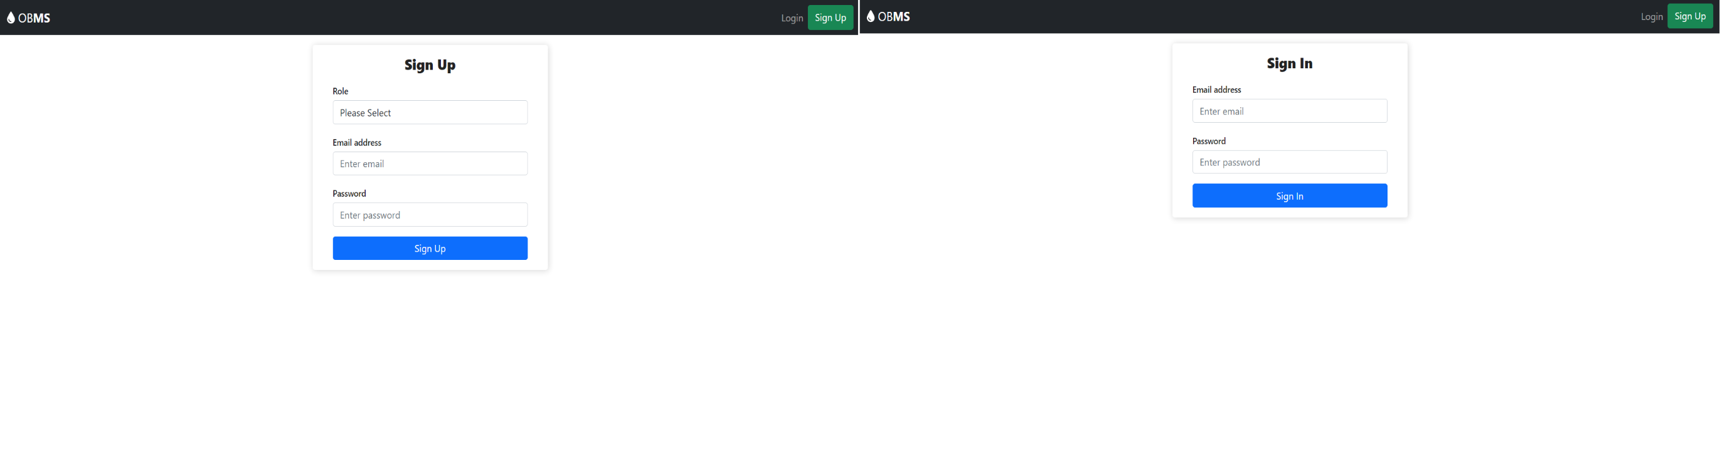

Figure Login Page

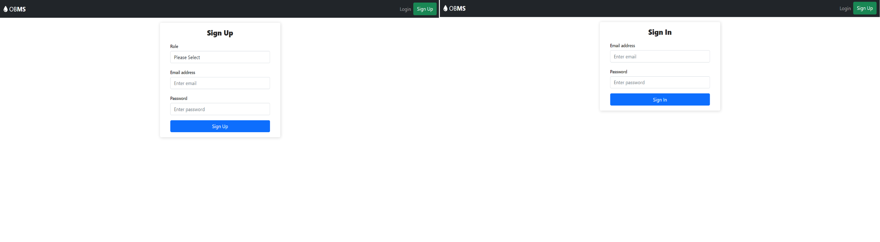

Figure Signup Page

Traversal within the app is through the navigation menu. The navigation menu is dynamic i.e., the menus will change based on the role of the user with the global administrator having a more generalized menu for management, health providers having navigation that reflects their administration activities with regards to the collection process, donors for scheduling appointments and medical professionals for both scheduling appointments and entry of test results.

A user profile page is provided for the individual users to update their basic details as necessary.

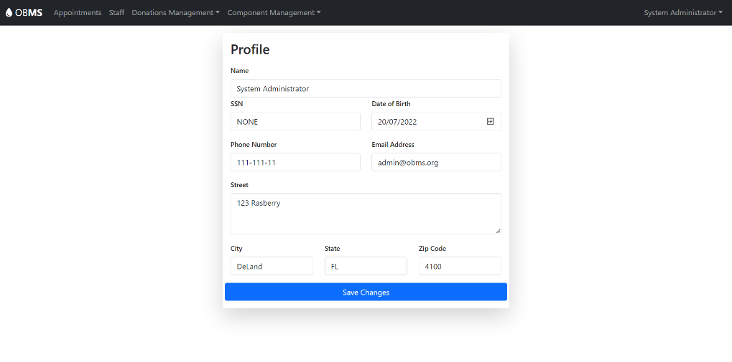

Figure Profile Update Page

A donation page for the global administrator to create and update the various donation types available across the entire system.

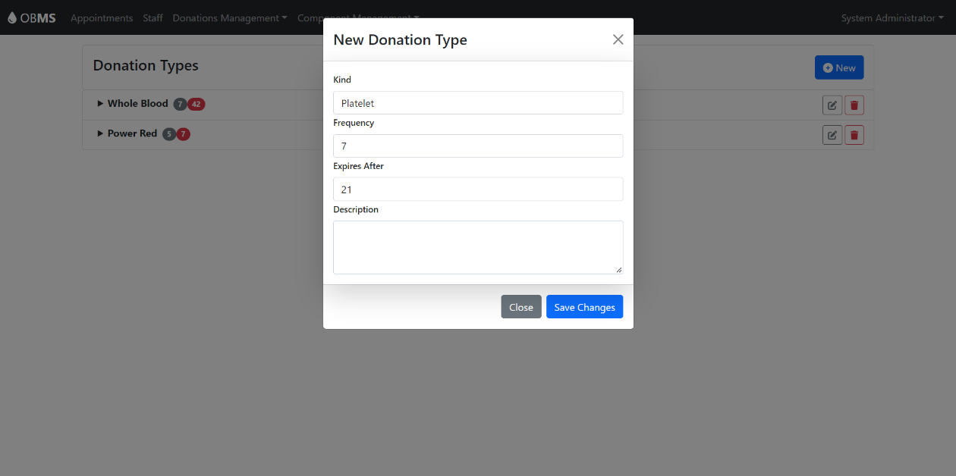

Figure Donation Component Page

# **Conclusion**

The paper presents a browser-based application that aims to streamline the process of blood donation. The design and implementation were made to make it as simple, easy to operate and maintain. As shown wastages in the donation process occurs due to use of siloed systems and this application has aimed to fix that by providing a centralized system that connects health providers, medical professional and donors.

# **Limitations and Future Works**

OBMS has some worthy additions some which are due to the arrival of new technology that will simplify the system further or due to our current technical limitations. These include:

1. **Implementation of mapping technology using Google’s Map:** this will help us triangulate the closet blood drive campaign centers based on donor current location and mode of transport thus helping potential donors make informed choices. This will entail implementing both Google’s Distance Matrix API together with the Google Maps API
2. **Implementation of Web Push Notification:** Though not available on Apple’s Safari browser, its implementation is mature in the other top 5 browsers. Implementation of this feature would enable pushing notification messages seamlessly to all the various end-users in a non-intrusive manner. Most importantly it would allow for sending of reminder notifications of appointments to potential donors, help in the implementation of direct donor request feature etc.
3. **Integration with third-party system especially those of the health providers:** This would entail developing a secure endpoint whereby third-party systems can pull from and push data into the system. Most notably is with regards to input of blood test results or retrieval from inventory of blood component for utilization; this will help reduce the errors associated with double data entry.
4. **Passwordless Authentication:** A new technology that is revolutionizing how we access protected systems. As our system does not and is not designed to support federated access, implementation of passwordless authentication will take it along way by easing end-users’ pain of managing multiple password credentials.

**References**

[1] World Health Organization. Towards 100% voluntary blood donation: a global framework for action. World Health Organization, 2010.

[2] World Health Organization: http://www.who.int (2014)

[3] Baş, Seda, Giuliana Carello, Ettore Lanzarone, Zeynep Ocak, and Semih Yalçındağ. "Management of blood donation system: literature review and research perspectives." Health care systems engineering for scientists and practitioners (2016): 121-132.

[4] Lozada, M. James, Stephanie Cai, Marissa Li, Stephanie Lynne Davidson, Justin Nix, and Glenn Ramsey. "The Las Vegas mass shooting: an analysis of blood component administration and blood bank donations." Journal of Trauma and Acute Care Surgery 86, no. 1 (2019): 128-133.

[5] Gillespie, Theresa W., and Christopher D. Hillyer. "Blood donors and factors impacting the blood donation decision." Transfusion medicine reviews 16, no. 2 (2002): 115-130.

[6] Stoto, Michael A., Harold C. Sox Jr, and Lauren B. Leveton, eds. "HIV and the blood supply: an analysis of crisis decisionmaking." (1995).

[7] Arif, Muhammad, S. Sreevas, K. Nafseer, and R. Rahul. "Automated online Blood bank database." In 2012 Annual IEEE India Conference (INDICON), pp. 012-017. IEEE, 2012.

[8] Győrödi, Cornelia, Robert Győrödi, George Pecherle, and Andrada Olah. "A comparative study: MongoDB vs. MySQL." In 2015 13th International Conference on Engineering of Modern Electric Systems (EMES), pp. 1-6. IEEE, 2015.

[9] MongoDB. NoSQL Database. https://mongodb.com

[10] Express.js. Program framework. https://expresjs.com

[11] React. JavaScript library. https://reactjs.org

[12] Node.js. Platform. https://nodejs.org

[13] Jones, Michael, John Bradley, and Nat Sakimura. Json web token (jwt). No. rfc7519. 2015.